THE RACE INVITATION
2. GRANFONDNO FALKENSTEINER BORIK - ZADAR REGION
24.10.2020

APPLICATIONS:
https://www.zadargranfondo.com/hr/registracija/

ENTRY FEE:
Pre-registered cyclists until February 22, 2020 | EUR 20.00
Registration from February 22, 2020 to May 31, 2020 | EUR 30.00
Registration from June 1, 2020 to August 14, 2020 | EUR 35.00
Registration from August 15, 2020 to October 23, 2020 | EUR 40.00

* Registration is not possible at the event spot.

By registering, competitors and clubs confirm that the competitor is medically fit, competitive and responsible for their own health.

Granfondo competitors who have booked accommodation with the host of the event - Falkensteiner Resort Borik - are entitled to the following discounts.

- 20% discount on entry fee for groups above 10 participants for stays of at least two nights at one of our hotels:

ACCOMMODATION:

Falkensteiner Premium Camping Zadar***** – Mobile Homes

- 59,00eur Camping Cozy Home – for two adults and a child

- 79,00eur Camping Family Home – for four adults and a child

Please emphasize that you book accommodation for GRANFODNO BIKE RACE.

Falkensteiner Club Funimation Borik****

- Novi park -
- Double room: 78,40 - € (standard double room)
Included HB
- Single room: 60,00,- € (standard double room)
Included HB
BARBARA -
- Double room: 87,20 - € (comfort double room)
Included HB
- Single room: 68,00,- € (comfort double room)
Included HB
Please emphasize that you book accommodation for GRANFODNO BIKE RACE.

TRAINING CAMP:
BORIK BIKE DAYS 2019
OFFER FOR 4 NIGHTS · 21.10. - 25.10.2020
Whether you are preparing for the upcoming multi-day bike race or just want to enjoy your bike ride, you will surely notice some new tricks and tips by pedaling along the unreal routes of North Dalmatia.OD € 99,65 po sobi/noćenju (minimalno trajanje boravka 4 noći)
• Cyclist welcome package
• Bicycle storage
• 1 Sports massage (30 min) per person
• 1 day bicycle tour with a group
• Afternoon station with pasta
• Admission to the race
• Winner ceremony

PLAN AND PROGRAM

21.10.2020
9.00 – 15.00 – cycling training, the group will be follow-up by the coach and they will start in front of the Club Funimation Borik Hotel
15.00 – 18.00 – info desk inside the Falkensteiner Club Funimation Borik

22.10.2020
9.00 – 15.00 – cycling training, the group will be follow-up by the coach and they will start in front of the Club Funimation Borik Hotel
15.00 – 18.00 – info desk inside the Falkensteiner Club Funimation Borik

23.10.2020
9.00 – 12.00 – cycling training, the group will be follow-up by the coach and they will start in front of the Club Funimation Borik Hotel
13.30 – 20.00 – info desk inside the Falkensteiner Club Funimation Borik
14.00 – 21.00 – pick-up their start packages, at the official office of the race inside the Falkensteiner Club Funimation Borik Hotel (compulsory ID and license)

24.10.2020
07.00 – 09.00 - pick-up their start packages, at the official office of the race inside the Falkensteiner Club Funimation Borik Hotel (compulsory ID and license)
08.00 – opening a bike zone for the race
08.30 – opening Ceremony (GM's opening speech to all competitors, and info program manager)
08.45 – 09.15 – official briefing in ENGLISH by the race referee
09.30 – RACE START (all categories start in the same hour)
13.00 – 14.00 - lifting bicycles from the secured bicycle race zone

14.00 – lunch at the Falkensteiner Club Funimation Borik for the racers
15.00 – GranFondo Falkensteiner Borik - Zadar County 2019 Race Ceremony (at the Falkensteiner Club Funimation Borik Hotel)

25.10.2020
10.00 – planned departure from Zadar

STARTING PACKAGE:
- backpack
- T-shirt
- a can
- start number
- timing chip
- Finisher medal
- race photos
- official time
- Lunch and awards ceremony

CATEGORIES:
MEN:
• Gentlemen: 15g-29g
• Gentlemen: 30g-39g
• Gentlemen: 40g-49g
• Gentlemen: 50g-59g
• Gentlemen: 60g +
LADIES:
• Ladies: 15g-34g
• Ladies: 35g-49g
• Ladies: 50g-64g
• Ladies: 65g +

PRIZES: Cups for the first three competitors in each category regardless of the number of participants in that age group, and a transition cup for the overall winner of the race.

Men's competition (these prizes apply to each category with 15+ drivers)
1st Place - 6 nights at Falkensteiner Club Funimation Borik for 2 people
2. Place - 4 nights at Falkensteiner Club Funimation Borik for 2 people
3rd Place - 2 nights at Falkensteiner Club Funimation Borik for 2 people

Women's competition (only one category)
1st Place - 6 nights at Falkensteiner Club Funimation Borik for 2 people
2. Place - 4 nights at Falkensteiner Club Funimation Borik for 2 people
3rd Place - 2 nights at Falkensteiner Club Funimation Borik for 2 people

ABOUT RACE:
Granfondo 120
Date: Subota, 24.10.2020.g.
Start time: 09:30h
Start: In front of the Falkensteiner Club Hotel Funimation Borik
Finnish line: In front of the Falkensteiner Club Hotel Funimation Borik
Length: 120km
Elevation gain: 1.034m

GPX STAZE:
https://www.strava.com/routes/22986642

PROFIL STAZE:
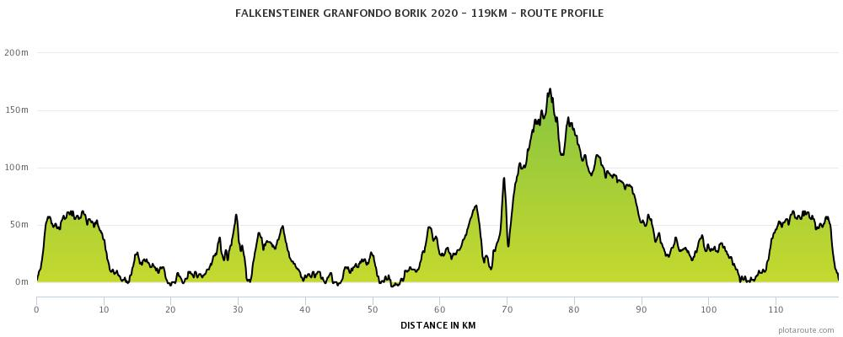

Granfondo 65
Date: Subota, 24.10.2020.g.
Start time: 09:30h
Start: In front of the Falkensteiner Club Hotel Funimation Borik
Finnish line: In front of the Falkensteiner Club Hotel Funimation Borik
Lenght: 65km
Elevation gain: 548m

GPX STAZE:
https://www.strava.com/routes/22986562

PROFIL STAZE:
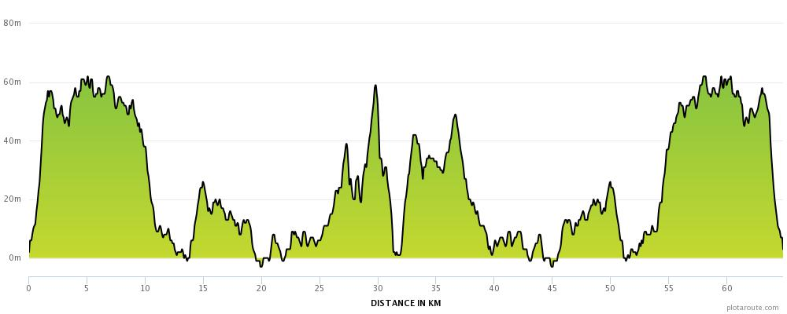

TIME MEASUREMENT: It will be performed automatically with the use of a computerized chip system by the "Protime" system.
http://www.protime.si

OPĆI PROPISI:
The event is subject to the HBS ROAD Technical Regulations and the UCI ROAD Rules and the UCI General Rules. Drivers start adopting these rules and driving at their own risk. The organizer is not responsible for the acts done by the driver towards third parties. The race is driven regardless of the weather. The Organizer reserves the right to change the race conditions without prior notice.

Complains:
According to the rulebook, in writing, with a deposit of 200 kuna. For complaints about events during the race - within 15 minutes of the finish. For results appeals - within 15 minutes after the result is published.

Additional notes and information:
a) The road will not be closed, mandatory driving in its lane.
b) Hazardous points on the track
- 32,5km SHARP RIGHT BEND at the bottom of the hill - danger
- 38.7km Sharp right bend (narrowing of road) - danger
- 51.8km SMALL ROTOR IN NIN - SHARP RIGHT RIGHT - DANGER
- 55.3km Pass under the ice - narrowing of the road
- 68.6km START OF THE RISE TO MATAK - BAD ROAD
- 70.0km BEGINNING OF THE RISE TO KAZANČAK - BAD ROAD
- 80.2km Turn left in RADOVIN - narrow road between the houses

c) There will be an official vehicle (yellow lamp) in the race that will be driven for up to 30 minutes behind the lead cyclist. All drivers behind the vehicle have no secured road safety and drive at their own risk, so they are asked to obey traffic regulations.

d) The final vehicle will be up to 60 minutes behind the leading cyclist. All cyclists left behind will be excluded from the race. Regardless, the direction marks on the course will remain for a certain period after the specified deadline.

e) Most challenging climbs:
- 32.8 - 34.6km -1.8km climb on Vir
- 68.6 – 69.3km – the ascent of Matakov's hill
- 70 – 71.2km – climb towards Razanac

By the act of the application, the competitor expressly states that:
• agrees to compete at the race about his or her risk and personal responsibility, and that he / she is aware of the rules and regulations of the race and the risks that such competition entails,
• waive the right to make a claim to the Organizer for compensation for any damages other than those whose occurrence could be attributed to the Organizer's intent or gross negligence,
• they will not hold the organizer responsible for the possible failure to meet their expectations or success in the race,
• the Organizer will not be liable for any direct or indirect, incidental, non-pecuniary or material damages, losses or costs of competitors,
• be in an appropriate psychophysical fitness appropriate for this type of competition,
• the organizer may use and process all recorded film and photographic material at no charge and publicly display and use it for promotional purposes of the race,
• the very act of filing waives the right to contest this Statement on any grounds.

