Falkensteiner Resort Borik

Majstora Radovana 7 · HR-23000 Zadar

Tel. +385/ (0)23/206 601

headoffice.croatia@falkensteiner.com

borik.falkensteiner.com

**NOTICE**

**4. GRANFONDNO FALKENSTEINER BORIK - ZADAR REGION**

**21.10.2023.**

Zadar, 09.10.2023

**APPLICATIONS:**

<https://www.zadargranfondo.com/>

**REGISTRATION PRICES:**

Pre-registered cyclists until April 30, 2023. EUR 35.00

Application from May 1, 2023, to August 31, 2023. EUR 45.00

Application from September 1, 2023, to October 20, 2023. EUR 60.00

*Registration at the event itself is not possible.

* By applying, competitors and clubs confirm that the competitor has been medically examined, is fit to compete and is responsible for his own health.
* Granfondo competitors who have booked accommodation with the host of the event

- *Borik* D.O.O - are entitled to the following discounts on the registration fee.

* + 20% discount on the entry fee for groups over 10 participants when staying at least two nights in one of our accomodation options:

**ACCOMMODATION OPTIONS:**

**a.) Falkensteiner Premium Camping Zadar***** – Mobile Homes**

* **66,30eur** Camping Cozy Home – for two adults and a child
* **102,00eur** Camping Family Home – for four adults and a child
* We offer various typologies of family accommodation and pitches, and for more details, please contact our Falkensteiner reservation center directly on the phone or visit our official page <https://www.zadargranfondo.com/falkensteiner-camping-premium-mobile-homes/>
* **For groups of at least 20 pax, we grant an additional discount** - for which please contact us directly at the following e-mail address: [maja.zubcic@falkensteiner.com](mailto:maja.zubcic@falkensteiner.com)
* Please emphasize that you are booking accommodation for the Granfondo race and use the following **PROMO CODE - GRANFONDO2023** when booking accommodation directly on our website.

**Contact:**

* Telephone: +385-91-220 6607
* Email: maja.zubcic@falkensteiner.com

campingzadar@reservations.falkensteiner.com

**B.). Falkensteiner Club Funimation Borik**

* **Superior double room seaside:**

158,00€ per room/day +2,66€ per room for residence tax

* **Family comfort room:**

149,00€ per room/day +2,66€ per room for residence tax

* **Family room standard:**

129,00€ per room/day +2,66€ per room for residence tax

* **Superior double room seaside single use:**

130,00€ per room/day +1,33€ per room for residence tax

**Service: All inclusive**

* We offer various typologies of family accommodation. For more details, please contact our Falkensteiner reservation center directly at the phone number or visit our official race website: <https://www.zadargranfondo.com/falkensteiner-club-funimation/>
* **For groups of at least 10 pax, we grant an additional discount** - for which please contact us separately and directly at the following e-mail address: [maja.zubcic@falkensteiner.com](mailto:maja.zubcic@falkensteiner.com)
* Please emphasize that you are booking accommodation for the Granfondo race and use the following **PROMO CODE - GRANFONDO2023** when booking accommodation directly on our website.

**Contact**

* Phone: +385-91-220 6607
* E-mail: [maja.zubcic@falkensteiner.com](mailto:maja.zubcic@falkensteiner.com)

**C). Hotel Donat**

* Double room (Economy) - €66.30 per room/day
* Single room (Economy): €38.25 per room/day
* Service: All inclusive (breakfast, lunch, dinner)

**Contact**

* Phone : +385-91-220 6607
* E-mail : maja.zubcic@falkensteiner.com

**TRAINING CAMP:**

OFFER FOR 4 AND 5 NIGHTS · 18.10. - 23.10.2023

* Whether you're preparing for an upcoming multi-day bike race or just want to enjoy cycling, you're sure to pick up a few new tricks and tips pedaling the incredible routes of the North Dalmatia.

**FROM € 135 per room/night (2 nights minimum stay)**

* + Welcome drink for cyclists.
  + Bicycle storage
  + - 20% on all Acquapura SPA treatments.
  + 1 day cycling tour with a group.
  + Afternoon station with pasta.
  + Winners' ceremony.
  + Daily isotonic drink per cyclist

**Link to register for the bike camp:**

<https://www.zadargranfondo.com/hr/trening-kamp/>

Meeting points:

* In front of the Club Funimation Borik Hotel
* Club Funimation Borik Hotel lobby
* Barbara bar in Club Funimation Borik Hotel

**GRANFONDO 2023 PROGRAM**

*Wednesday, October 18, 2023*

* 15.00h - 18.00h - Info desk inside Falkensteiner Club Funimation Borik hotel
* 15.00h- 19.00h - Cycling training 3-4 hours, the group with an escort starts in front of the Club Funimation Borik hotel
* 19.00h - 21.00h - Dinner

*Thursday, October 19, 2023*

* 07.00h - 08.00h Breakfast
* 08.30h - 13.00h - Bicycle training PASSAGE OF THE ENTIRE GF PATH (large 112km or small 56km), the group with an escort starts in front of the Club Funimation Borik Hotel
* 13.00h - 13.30h - Stretching (30 min) **
* 13.30h - Lunch
* 15.00h - 17.00h – Realaxation at Acquapura SPA center
* 15.00h - 18.00h - Info desk inside Falkensteiner Club Funimation Borik Hotel
* 19.00h - 21.00h - Dinner

*Friday, October 20, 2023*

* 07.00h - 08.00h - Breakfast
* 08.30h - 11.00h - Bicycle training, the group with an escort starts in front of the Falkensteiner Club Funimation Borik hotel/ light training ride and a tour of the sights of Zadar
* 11.00h - 11.30h - Stretching (30 min) **
* 12.30h - Lunch
* 15.00h - 17.00h – Realaxation at Acquapura SPA center
* 14.00h - 21.00h -Pick up start packages, at the official race office inside the Falkensteiner Club Funimation Borik hotel (mandatory ID card and license for licensees)
* 15.00h - 18.00h - Info desk inside Falkensteiner Club Funimation Borik
* 18.30h - 21.00h - Dinner

Saturday, October 21, 2023

**RACE DAY: GRANFONDO FALKENSTEINER BORIK 2023**

* 07.00h - Breakfast
* 07:00h - 09:00h - Pick up of start packages, at the official race office inside the Falkensteiner Club Funimation Borik
* 09.00h - Opening of the cycling zone for the race
* 09.30h - Ceremonial opening of the race (ceremonial speech by the GM to all competitors, and info from the program manager)
* 09.45h - Official briefing in ENGLISH by the main judge of the race
* **10.00h - START OF THE RACE (all categories start at the same time)**
* 13:00h. - 14:00h - Picking up bicycles from the secured area of the bicycle race.
* 12:30 - 2:30 p.m. - Lunch at the Falkensteiner Club Hotel Funimation Borik for race competitors
* 15.00h - Ceremonial announcement of the winner of the 3rd GranFondo Falkensteiner Borik – Zadar County 2022 race (on the stage of the Falkensteiner Club Funimation Borik)

*Sunday, October 22, 2023*

* 7.00h - 10.00h - Breakfast
* 10.00h - Planned departure from Zadar

**START PACKAGE:**

* Backpack
* T-shirt
* Water bottle
* Start number
* Timing chip
* Finisher's medal
* Photos from the race
* Official time
* Festive lunch and awards ceremony

**CATEGORIES:**

***ABSOLUTE CATEGORY:***

***GranFondo Falkensteiner Borik – Zadar Region 2022 Classic Gran Fondo 112km***

MEN:

* Gentlemen: 15-34 years
* Gentlemen: 35-49 years
* Gentlemen: 50-59 years
* Gentlemen: 60+

LADIES:

* Ladies: 15-37 years
* Ladies: 38-54 years
* Ladies: 55+

***Small Gran Fondo 56km***

MEN:

* Gentlemen: 15-45 years
* Gentlemen: 46+

LADIES:

* Ladies: 15-40 years
* Ladies: 41 years+

**PRIZES:**

* Trophies for the first three competitors in each category, regardless of the number of participants in that age group, and a transitional trophy for the overall winner of the race.
* Men's competition (these awards are valid for each category in which there are 15+ drivers)

**1st Place – 4 nights at Falkensteiner Club Funimation Borik for 2 people**

* Women's competition (these awards are valid for every category in which there are 10+ female drivers)

**1st Place – 4 nights at Falkensteiner Club Funimation Borik for 2 people**

**ABOUT THE GRANFONDO 112KM RACE:**

* Granfondo 112
* Date: Saturday, October 21, 2023.
* Start: 10:00h
* Starting point: In front of the Hotel Falkensteiner Club Funimation Borik
* Destination: In front of the Hotel Falkensteiner Club Funimation Borik
* Length: 112 km
* Altitude difference: 839m

**GPX TRAILS:**

https://drive.google.com/file/d/1fwxh65RmZOyMTuG2K_-NTdhhJMmJec6R/view?usp=sharing

https://www.strava.com/routes/3016819148548468916

**PROFILE OF THE TRAIL:**

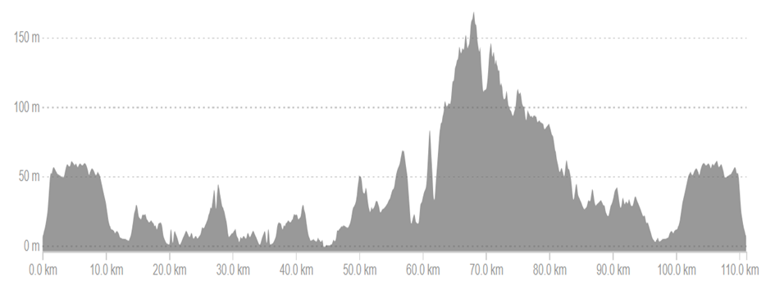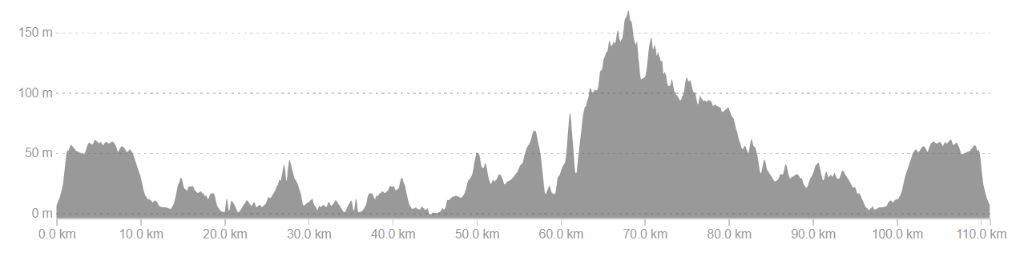

**ABOOUT Granfondo 56KM RACE:**

* Date: Saturday, October 21, 2023.
* Start: 10:00 am
* Starting point: In front of the Hotel Falkensteiner Club Funimation Borik
* Destination: In front of the Hotel Falkensteiner Club Funimation Borik
* Length: 56 km
* Height difference: 348m

**GPX TRAILS:**

https://drive.google.com/file/d/1QjG25J_r7iAEDY6XKpIfDq5KUIDWMHix/view?usp=sharing

https://www.strava.com/routes/2877637557938859150

**PROFILE OF THE TRAIL:**

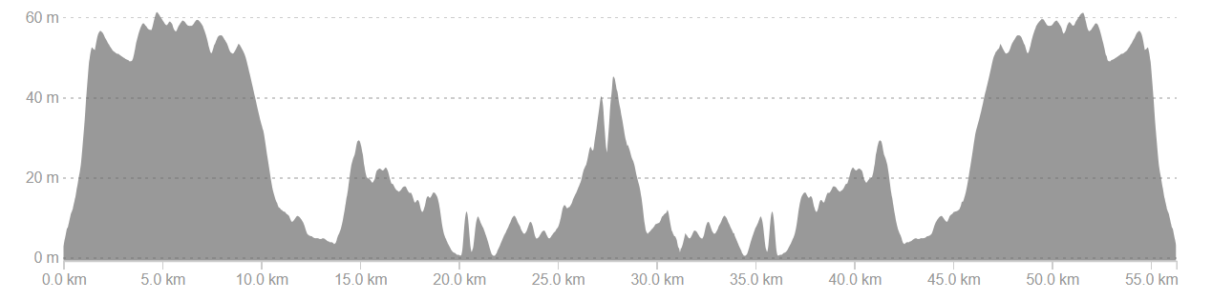

**TIMING:**

It will be carried out automatically using a computerized system with chips by the "Protime" system.

<http://www.protime.si>

**GENERAL REGULATIONS:**

The ROAD technical regulations of HBS and the ROAD UCI regulations and the general rules of the UCI apply to the event. Drivers adopt these propositions at the start of the race and drive at their own risk. The organizer is not responsible for acts committed by the driver towards third parties. The race is run regardless of weather conditions. The organizer reserves the right to change the conditions of the race without prior notice.

**Complains:**

According to the regulations, in writing, with a deposit in the amount of 50 euros. For complaints about events during the race - within 15 minutes after the finish. For appeals about the results - within 15 minutes after the results are announced.

**Additional notes and information:**

**a) The road will not be closed; you must drive in your own lane.**

**b) Dangerous points on the track**

- 24.5km ENTRANCE TO VIR CENTER - NARROWING - DANGER

- 27.3km SHARP TURN TO THE LEFT – BEGINNING OF A SHORT HILL

- 42.5km DIVIDED INTO A SMALL (goes straight) and BIG TRACK (goes left)

- 43.7km SMALL ROUNDABOUT IN NIN - SHARP CURVE TO THE RIGHT - DANGER

- 44.0km BIG ROUNDABOUT – AROUND THE ROUNDABOUT THEN TO THE LEFT EXIT TOWARDS VRSI

- 47.3km PASSAGE UNDER SLAVOLUK - narrowing of the road

- 49.0-50.0km AFTER ARCH 5 LARGE LYING POLICEMEN

- 60.7km BEGINNING OF THE CLIMB TO MATAK - BAD ROAD

- 62.1km BEGINNING OF THE CLIMB TO RAŽANC - BAD ROAD

- 72.9km TURN LEFT INTO RADOVIN - narrow road between houses

- 87.0km ROUNDABOUT MAZIJA - TURN RIGHT

- 96.7km ROUNDABOUT IN NIN - STRAIGHT PASS

- 97.0km ROUNDABOUT IN NIN – EXIT THREE TO THE LEFT

- 111.5 - 111.9km ENTRY TO THE TARGET 2 DANGEROUS BEND

**c)** During the race, an official vehicle (yellow lamp) drives in front of the cyclists, which ensures safe passage and follows the leading cyclists and the main group. Cyclists are also accompanied by vehicles with HBS judges whose instructions all race participants must follow. All competitors who fall behind the main group are obliged to comply with traffic rules and the instructions of the stewards on motorcycles and on the road.

**d)** On both tracks, a final vehicle (broom/broom) accompanies all the competitors.

**e) The most demanding climbs:**

- 27.3 - 27.8km – short climb to Vir

- 60.7 – 61.4km – climb to Matak's brig

- 62.1 – 64km – ascent towards Ražanac

Results: online at [www.protime.si](http://www.protime.si)

**By the very act of application, the contestant expressly declares that:**

* Agrees to compete in the race at his own risk and personal responsibility, and that he is familiar with the rules and regulations of the race and the risks that such a competition contains,
* Waives the right to ask the Organizer for compensation for any damage, except for that which could be attributed to the Organizer's intention or gross negligence,
* The organizer will not be held responsible for the possible failure to fulfill their expectations or success in the race.
* The organizer will not be liable for any direct or indirect, accidental, immaterial, or material damage, losses or expenses of the competitor,
* That he is in adequate psychophysical condition suitable for this type of competition,
* The organizer can use and process the entire filmed and photographic material without any compensation and publicly show and use it for the promotional purposes of the race,
* By the very act of application, waives the right to refute this Statement on any basis.